**Feeding Experimentation Device (FED)**

Protocol updated Sept 24, 2016

**Contributors:**

Katrina P Nguyen

Timothy J O’Neal

Julia A Licholai

Ilona Szczot

Mohamed A Ali

Elecia White

Alexxai V Kravitz

**Funding:**

Development of FED was funded by the National Institutes of Health Intramural Research Program

**SHORT DESCRIPTION:**

Feeding Experimentation Device (FED) is an open-source device for measuring food intake in mice. FED can also synchronize food intake measurements with other techniques via a real-time digital output. Here, we provide a step-by-step tutorial for the construction, validation, and usage of FED.

**ACKNOWLEDGMENTS:**

Funding was provided by the Intramural Research Program at the National Institutes of Health. We thank the NIH Section on Instrumentation and the NIH Library for assistance with 3D printing, and all members of the Kravitz lab for general help with FED.

**DISCLOSURES:**

The authors declare no conflict of interests, financial or otherwise.

**PROTOCOL:**

Note: This protocol is written for components specifically named in the Table of Materials. While similar functionality can be achieved using other hardware, FED is programmed with the Arduino Pro microcontroller and listed accessories. Other microcontrollers should work equally well, but will require the user to modify the code to support them. Offline data analysis was coded using the Python programming language.

1. **Preparation** 
   1. Procure electronic components needed to construct FED (see **BoM** at: https://github.com/KravitzLab/FED/tree/master/doc).

Note: Alternative suppliers may be used for many parts on this table, provided they have identical specs.

* 1. Print 3D designed components (available at: <https://github.com/KravitzLab/fed/wiki/Build-Instructions>). 3D printers with a 200 micron resolution should be capable of printing FED

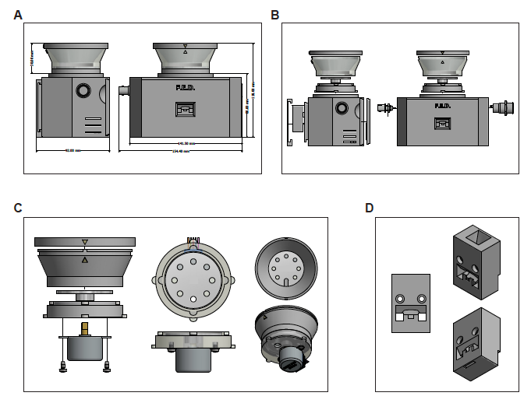

* 1. Download and install the Integrated Development Environment (IDE) platform to program the microcontroller.
  2. Download and install additional libraries to enable functionality of motor shield and data logger (available at: <https://github.com/KravitzLab/fed/>).
  3. Tools needed for assembly include: a soldering iron, heat gun, solder, wire strippers, needle-nosed pliers, and both flat-head and Phillips screwdrivers.

1. **Soldering electrical components**

Note: Use heat shrink tubing to protect all soldered joints. Prior to soldering connections, slide a piece of shrink wrap tubing (~2cm) tubing around one of the wires. After soldering the connection, center the tubing on the connection point and use a heat gun to heat shrink the tubing.

* 1. Microcontroller and stackable shields:

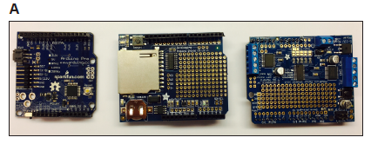

* + 1. Solder stackable headers onto the top side of the microcontroller and SD card data logging shield. Clip protruding wire from headers on the bottom of the microcontroller board.
    2. Place coin cell battery into slot of SD shield to provide power to the real-time clock module.
    3. Solder male headers onto the motor shield with pins protruding from the bottom.
    4. Create a ground strip on the prototyping area of the motor shield by soldering a piece of bare wire from the peripheral ground (near D13) along the row of through holes.

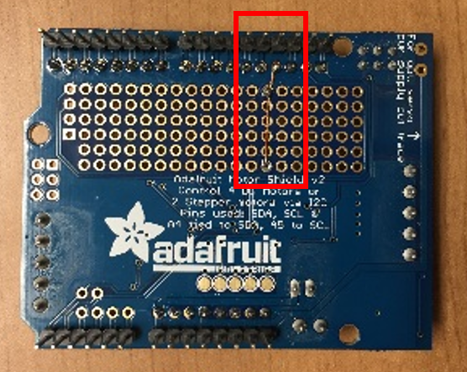

* 1. External power button:

Note: A latching metal pushbutton has five connections: power, ground, normally closed (NC1), normally open (NO1), and common (C1).

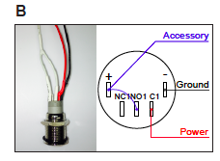

* + 1. Solder female half of the 2-pin connector to common (C1, red) and ground (black), and solder a 10-cm wire to the (+) pin (this will provide power to the Arduino once the switch is depressed.) Heat shrink all connections.
    2. Add a short jumper wire between the (+) terminal and NO1 (this will illuminate the LED in the switch when FED is powered). Heat shrink all connections.
  1. Photointerrupter:

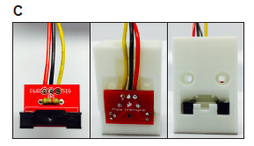

* + 1. Solder photointerrupter to breakout board.
    2. Solder a 4.7K resistor to the front of the breakout board.
    3. Solder three 10 cm long wires to the back of the breakout board: power (PWR), ground (GND), and signal (SGL).
  1. Boost board
     1. Solder the male half of the 2-pin connector to the 5V and Ground pins on the boost board.

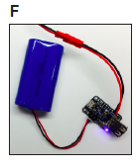

* 1. BNC output cable (optional):

Note: if a BNC output is not desired, print a plug to cover the side hole.

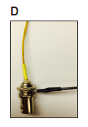

* + 1. Solder a 7 cm wire to the signal connection of the BNC female chassis mount connector and heat shrink connection; solder another 7cm wire to the outer ground ring.

1. **Software upload**
   1. Stack data logger shield on top of the microcontroller.
   2. Connect the FTDI breakout board to the programming pins of the microcontroller, and then connect FTDI breakout board to computer via micro USB cable.
   3. Open the IDE (integrated development environment) program.
   4. Select the correct microcontroller board for software upload through Tools > Board dropdown menu.
   5. Select the port that the microcontroller is connected to through Tools > Port > COM# (will vary depending on which port is currently in use).
   6. Upload the FED sketch to the board (available at: <https://github.com/KravitzLab/fed/tree/master/fed-arduino>).
2. **Hardware assembly**
   1. Stepper motor and motor shield (**Figures 1C and 2E**):
      1. Secure a 5V stepper motor onto the 3D printed motor mount with two self-drilling screws.

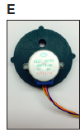

* + 1. Insert rotating disk into motor mount and push down to securely attach to stepper motor shaft.
    2. Twist on 3D printed food silo onto the motor mount making sure the pellet leveler arm is over the hole in the motor mount.
    3. Twist on connected pieces from above (steps 4.1.1 – 4.1.3) to the top of the printed base, with the stepper motor positioned towards the back of the base and the hole positioned in the front.
    4. Connect outputs from the 5-pin cable connector on the stepper motor to the terminal block connectors on the motor shield: red to ground, orange and pink to one motor port (e.g., M3), and blue and yellow to the other motor port (e.g., M4).
  1. External power button:
     1. Insert power button from the outside in, on the right side of the 3D printed base. Secure button in place with hex nut.
     2. Solder the signal wire (C1) to the voltage-in pin (Vin) on the motor shield.
  2. Photointerrupter:
     1. String the three wires from the photointerrupter (PWR, GND, and SGL) through the front middle hole of the 3D printed base.
     2. Connect wires from the photointerrupter to the motor shield: signal, power, and ground from the photointerrupter to D2, 5V, and GND on the motor shield, respectively.
  3. BNC output cable:
     1. Insert BNC from the outside in on the left side of the 3D printed base. Screw ground ring and hex nut from the inside to secure in place.
     2. Solder signal and ground wires from the BNC to D3 and ground on the motor shield, respectively.
  4. Battery:

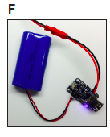

* + 1. Connect 3.7V battery pack to the DC/DC boost converter module via the JST 2-pin connection.
    2. Supply power to the system by connecting the male and female 2 pin connectors.
  1. 3D printed FED components:
     1. Insert photointerrupter arms through the back of the food well and secure in place with two nylon machine screws and hex nuts (**Figure 2C**). Heating up the food well with a heat gun can help secure it in place if the fit is tight. Slide on the 3D printed face plate.

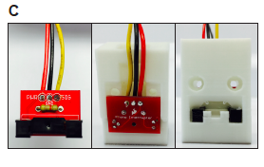

* + 1. Separate Arduino Pro from the other shields, and mount inside the base using steel mounting screws.
    2. Stack motor shield and data logger shield on top of the pro.
    3. Place the battery and boost board inside the 3D printed base and slide the back cover closed (**Figure 2G-H**).

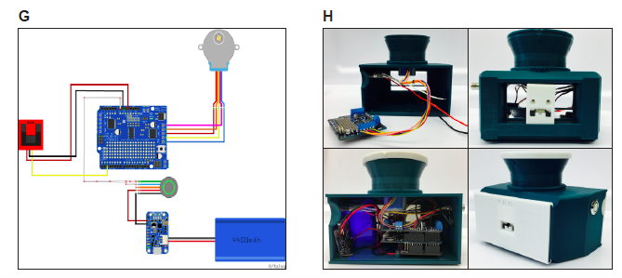

* + 1. Fill food silo with pellets (20 or 45 mg, depending on the disk used) and cap.

1. **Validation and data acquisition**

Note: Prior to powering on a FED system, ensure an SD card is inserted on the SD shield; otherwise FED will not dispense pellets. Additionally, ensure power jumper on the motor shield (just above the power block) is in place.

* 1. Power on FED system with the power pushbutton and test device functionality:
     1. Manually remove 5-10 pellets from food well and confirm that replacement pellets are dispensed.
  2. Remove SD card and verify that data was logged properly. Data should be acquired in a comma-separated value (.CSV) file named according to the date and start time of each device.
  3. Place FED unit inside experimental setting and power on. Ensure that a pellet is dispensed into the food well.
  4. Over the course of data acquisition, check FED daily to verify that it is working properly by confirming that (1) the LED light on the power switch is on, indicating that the battery has enough charge, and (2) a pellet is sitting in the food well, indicating that there are no problems with pellet dispensing.
  5. After data acquisition, retrieve SD card and access .CSV file
  6. We provide analysis scripts for meals and patterns of feeding at: <https://github.com/KravitzLab/fed/>.